F. Kenneth Iverson (1925-2002)

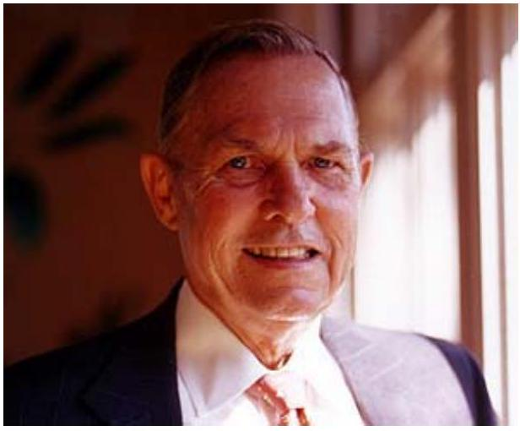
John Correnti, CEO Nucor, quoted by John H. Sheridan, "Tale Of A'Maverick,'" Industry Week, June 8, 1998.
When [they] open up the history books, our grandchildren, 30 or 40 years from now, are going to open it up to 'Steel in America,' and they're going to see two names and two pictures. They are going to see Andrew Carnegie, father of the integrated industry, and Ken Iverson, father of the American mini-mill. That's just the way it's going to be.
Kenneth Iverson received a B.S. in aeronautical engineering from Cornell University and a master's degree in mechanical engineering from Purdue. He served in the U.S. Navy during World War II and began his business career with International Harvester as a researcher. After that, he held a number of jobs in the metals and metalworking industry.
In 1962, Iverson joined Nuclear Corp. of America as vice president, overseeing the Vulcraft division. Iverson became president in 1965, and the company changed its name to Nucor in 1972.
Vulcraft produced steel grates and joists, not steel. Iverson started the company's minimill operations because he wanted low-cost steel for the firm's products. By the end of his tenure with the company in 1999, it had become the second-largest steel producer in the U.S.
Until the advent of mini-mills, steel was manufactured in large integrated facilities. An integrated facility took in iron ore, coke, and fuel as inputs and produced pure steel ingots as an intermediate product. The steel ingots were then converted into various shaped products: sheet, rod, girders, tube, wire, grate, etc. In contrast to integrated mills, mini-mills used scrap steel, mainly from old automobiles, as input. In a mini-mill, an electric furnace melted and purified the scrap steel. Construction costs per ton for a mini-mill were only a fraction of those for an integrated mill. However, obtaining high-quality steel from a mini-mill was not easy, and mini-mills initially sold only the lowest grades of steel.
Stuart Brown, "Steel Technology is Red Hot," Fortune, May 13, 1996.
Essentially recyclers, the minis rely mainly on scrap metal for raw material that lets them operate comparatively uncomplicated plants.
Nucor's mills are the most productive in the world, cranking out flat-rolled metal with a labor input of just 0.6 manhours per ton.... Recycling gave the minis their original edge. Making new steel requires the daunting manipulation of oxygen and carbon molecules. Iron ore as found in the ground is chemically identical to iron oxide, i.e., rust. An integrated producer uses coke, essentially pure carbon produced from coal, to strip oxygen molecules from the ore in a blast furnace. The iron's carbon content must then be burned away in a so-called basic oxygen furnace to form steel. All this requires platoons of workers as well as big-ticket facilities, which the minis don't need.
In the 1970s, mini-mills began to sprout up around wrecking yards and other places where scrap or electricity was cheap. It was clear to everyone that these low-cost facilities would take business away from importers and some U.S. manufacturers in low-grade steel. But there weren't any large firms interested in building mini-mills-there simply were no economies of scale in the business. The history of steel was one of ever-larger facilities garnering lower and lower unit costs. Mini-mills promised almost perfect competition among a large number of undifferentiated competitors: a strategist's nightmare.
John H. Sheridan, "Tale Of A'Maverick,'" Industry Week, June 8, 1998.
While working on his master's degree in mechanical engineering at Purdue University, Ken Iverson got his first closeup look at steelmaking during a field trip to a large integrated mill in Gary, Ind. The year was 1947 -- and he wasn't overly impressed with what he saw.
"It was late afternoon," he told a Purdue alumni publication some years later. "Going through the plant, we actually had to step over workers who were falling asleep there. I decided right then that I didn't ever want to work for a big steel company." As fate would have it, F. Kenneth Iverson did wind up working for a big steel company. In fact, he built one.
Iverson saw what others did not, turning the absence of economies of scale into an advantage. By building a number of small plants, Nucor avoided the old rust-belt labor culture and let each plant's workforce see and experience local productivity levels. In addition, Nucor pursued a major plant construction or improvement project each year. Consequently, over time, Nucor became the most experienced company in the world at building new steel facilities and bringing them online.
Over the years of Iverson's tenure, Nucor not only grew; it also became more efficient. Some of this efficiency edge came from deploying new technology, but more came from the company's management system. Its lean style and high-intensity incentives not only generated hard work but also a constant flow of production innovations.
Pankaj Ghemawat and Henricus J. Stander III, "Nucor at a Crossroads," HBS Case, 1998.
Nucor made strenuous efforts to minimize status-related differences among its employees. Everybody received the same insurance coverage and holidays. On the factory floor, everybody wore green spark-proof jackets and hard hats (unlike integrated mills, where different colors signaled different levels of authority). There were no assigned parking places or company cars, boats or planes. All air travel was in coach class and frequent flyer awards earned on business travel were redeemed for future business travel. Corporate headquarters still consisted of a rented suite of offices in the building Nucor had moved into in 1966 and Phil's Deli, across the street in a shopping center, served as the executive dining room. Iverson answered his own phone and along with the other officers promised to get an answer to any employee's question within 24 hours. Each year's annual report listed all employees on its cover in alphabetical order.....
Nucor's compensation systems were designed to reward production groups, rather than individual workers, for exceeding predetermined productivity and quality standards. The standards were typically based on experience rather than formal time studies and were not revised unless there was a major machinery change. Less than $5\%-10\%$ of the standards were changed in any given year.
No bonus was paid when equipment was idle. Since incentive bonuses could average $80\%-150\%$ of base wages, cash compensation was slightly higher on average for Nucor's nonunionized production workers than for unionized steelworkers at integrated steelmakers, even though Nucor's base wage per hour was significantly lower. Nucor reinforced these rewards with stiff penalties: anyone late for a shift lost a day's bonus, anyone who missed a shift lost the bonus for the week, and if a group fell short of its productivity goal, all its members lost their bonuses for the week. It further reinforced the relationship between pay and performance by paying bonuses every week (with green checks) and by continually reminding workers of their progress. At the entrance to each plant hung a giant board that depicted each group's weekly productivity gain, their bonuses, the plant's performance relative to the target of $25\%$ return on assets, the company's return on equity for the month, and the latest stock price.
Nucor’s turnover ran 1% to 5% a year—about half the rate common in U.S. steel. Most losses came early, among new hires; once people stayed, they tended to stay, and the plants got better. Management’s policy was simple: keep steady hands, and in downturns cut hours instead of cutting jobs. Bonuses continued even in short weeks, so pay might drop 15% to 20%, but employment did not. The result was a workforce that trusted the system and a company that kept its operating capability intact.
Iverson's management philosophy was simple to state and frequently featured in the company's publicity. He believed in few layers of management and in egalitarian working conditions. He believed that loyalty was a two-way street and came only in an environment of trust. He believed in strong incentives, with productive work groups earning more than managers. Workers were paid on the basis of production, and managers on return on investment. He believed in experimentation and risk-taking. He believed in focus-the firm did not diversify, grow by acquisition, or go abroad.
Tom Brown, "The Art of Keeping Management Simple," Management Update, Harvard Business School Publishing, May 1998
Iverson's keys to managing simply.
Destroy hierarchy: management exists to help workers do their jobs.
Hierarchy induces executives to focus on perks instead of performance.
"Employees-not managers-are the engines of progress," Iverson emphasizes.
The only reason a manager exists is "to help the people you manage... accomplish extraordinary things." You need trust to operate efficiently.
Iverson chose a corporate headquarters removed from Nucor's operational centers in order to give his general managers the freedom to manage as efficiently as possible. This action said "I trust you" to Nucor's general managers-Iverson never had to utter the words. And the same applies to the general managers.
Whenever a key manager was terminated, it was because he lost the trust of those he managed-"the employees fired the general manager," says Iverson.
Give workers a stake in the success of the business.
That's what motivates them the most.
Give all workers a way to earn an above average income, job security, and the chance to be promoted.
Centralization vs. decentralization is not the issue-decisiveness is.
Iverson doesn't care if some functions are centrally managed at one division and decentralized at another. Instead, he requires division managers to choose- decide "where the locus of decision-making power should reside"-and then "stick to their choice." Don't overlook the virtues of smallness.
Nucor more closely resembles a conglomerate of smaller companies than a major corporation. The key, says Iverson, is not to fixate on the size of the business at any level: "Look for ways to make the strengths of size and the virtues of smallness work for you."
Nucor's efficiency drove rapid growth during the 1970s and 1980s, and through the first half of the 1990s. Warren Buffett owed a substantial chunk of his fortune to gains in Nucor's stock price. In 1991, Iverson awarded the presidency of Nucor to John Correnti, an ardent supporter of Iverson's management style. David Aycock was passed over for the job and left the company.
During 1995-99, as tech stocks bubbled, Nucor's performance leveled off. The reasons were not mysterious and had long been predicted by those who studied the company. As more mini-mills came online, scrap prices rose. As Iverson's management practices became well known, other mini-mills began to adopt them. New innovations in steel technology allowed integrated mills, having shed 90% of their employees and facilities over 30 years, to begin to compete with mini-mills at last.
In 1996, Correnti became CEO of Nucor, leaving Iverson as chairman. Although their management principles stressed egalitarianism, the company's strategy remained firmly in their hands. However, as earnings growth slowed, challenges to Iverson and Correnti's strategic control arose. In 1998, the Teachers Insurance and Annuity Association College Retirement Equities Fund (TIAA-CREF) placed increasing pressure on Nucor to diversify its board beyond "five white men." In the spring, three new board members were added, including two minorities. The new members tipped the balance of power on the board against Iverson, and in January 1999, Iverson was forced to retire. His handpicked successor, John Correnti, was also pushed out from his position as CEO. David Aycock, 68, became chairman and CEO of Nucor.
Aycock was convinced that Nucor had to break with the past to meet the aggressive growth goals the board had set. To continue to grow rapidly, he noted, Nucor would have to make acquisitions, look at foreign facilities, and, probably, build its own integrated steel mill.
The change in management at Nucor drew mixed reactions. To many Wall Street analysts, Nucor was a "growth" company, and any change promising more growth was welcome. Others saw it as a mistake. Adam Ritt (New Steel, July 1999) wrote that "The outside directors should have spent more time learning what made Nucor successful. They should have waited to evaluate the company's performance in the coming months before taking the word of Aycock, Siegel, and Hlavacek that Correnti wasn't the man to lead the company. If the purpose of adding outside directors is to give the board an independent voice, this initiative failed. All the new directors became Aycock's allies in unseating two of the best executives the steel industry has known."
By mid-2000, Nucor had expanded to become the largest steel producer in the United States, overturning the century-long leadership of U.S. Steel. Aycock added five senior executives to bolster executive functions at Nucor. Jeff Kemp (44), with experience in chemicals, was given the job of spearheading business development. Kemp said "I will assist the management of Nucor in looking for opportunities for growth... We'll look at extensions of the current business line and then go farther afield."
The new Nucor management team was considering constructing a large pig-iron plant in Brazil and a new steel mill between Chicago and Detroit.
Comments on Aycock's Initiatives in Timothy Roberts, "Steeling for Change," Charlotte Business Journal, December 20, 1999
Iverson, 74 and retired, takes a dim view of most of the initiatives. A drop in the cost of scrap makes it unnecessary to build a pig iron plant, he says. A steel mill near Chicago is "idiotic," he says. Chicago has the highest electrical costs in the whole Midwest, he says, and it is heavily unionized. "That's a dumb idea," he says.
But he saves his biggest criticism for the expansion of management. "I just don't believe in having many management layers," Iverson says. "It makes for difficult and bureaucratic government over the divisions. We were never short of planning. We did a good job of planning. The company progressed very satisfactorily."
Correnti, who has just won a proxy fight to become chairman of Nucor rival Birmingham Steel, also recoils at the idea of more staff at the corporate headquarters. "Nucor is trying to centralize and do more mentoring," he says. "That's not what grew the company to what it is today." The decision on the Midwest plant proves the point, Correnti says. Aycock has been talking about it for a year, without taking any action -- and that's an eternity to fast movers like Correnti and Iverson. "Nucor is becoming a typical corporate entity with all the various levels of management and a pecking order," Correnti says. "They won't be able to move as fast. They will have more informed decisions but fewer successes. They'll have fewer strikeouts but fewer home runs." Correnti has been on the job at Birmingham Steel for just a week and already is contemplating what to do about a headquarters staff of 156, a number that he says is "way, way, way too many."
After leading a proxy fight to take over Birmingham steel in 2000, Correnti sold the company to Nucor in 2002 for $\$615$ million, a $25\%$ gain over the take-over price. Also in 2002, Kenneth Iverson died at age 76.
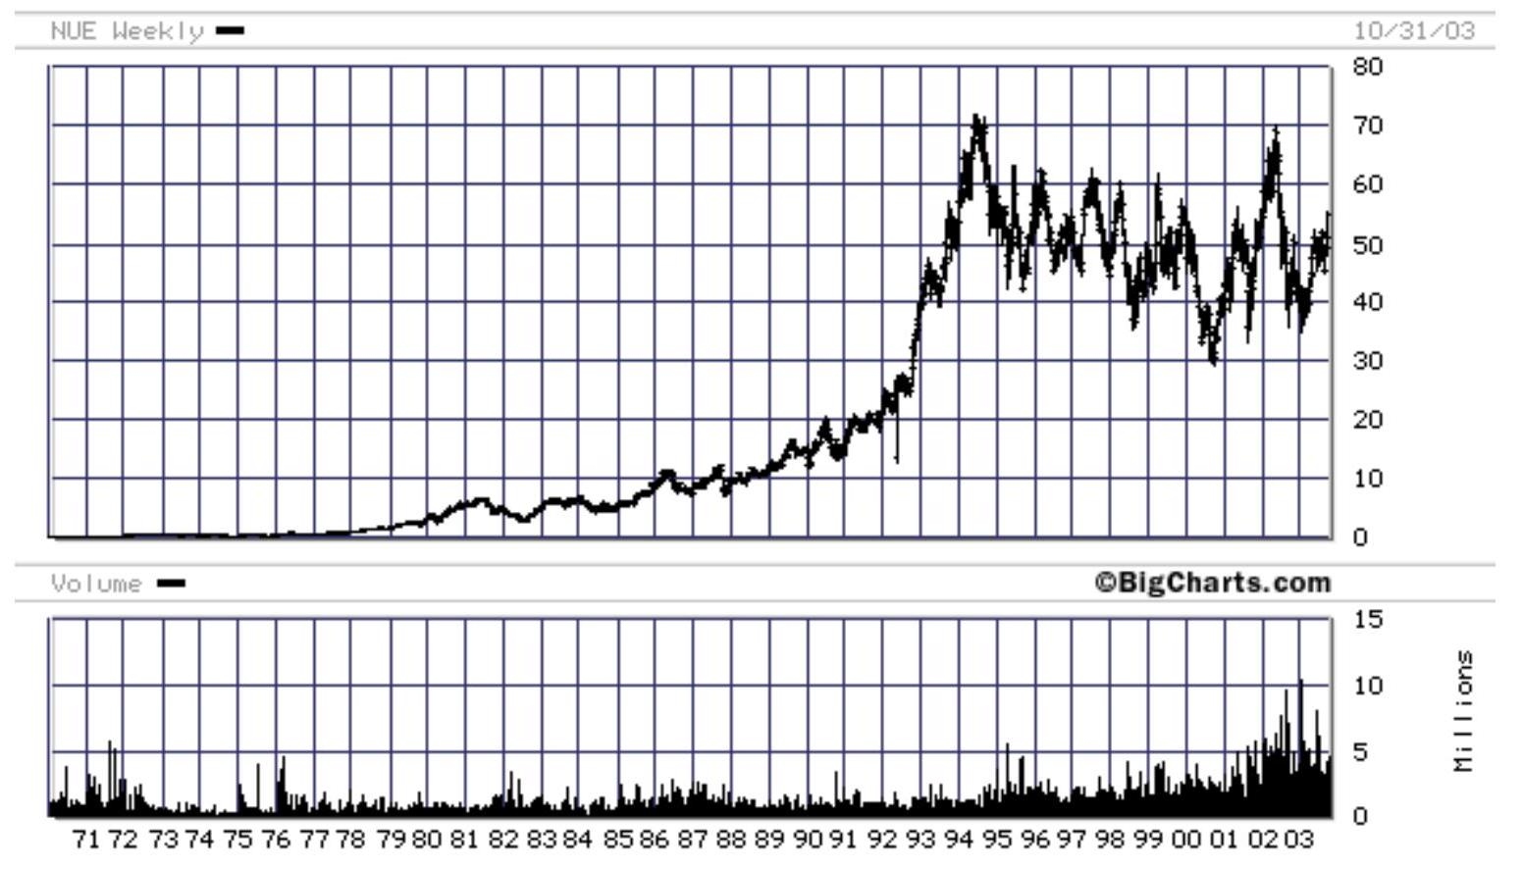

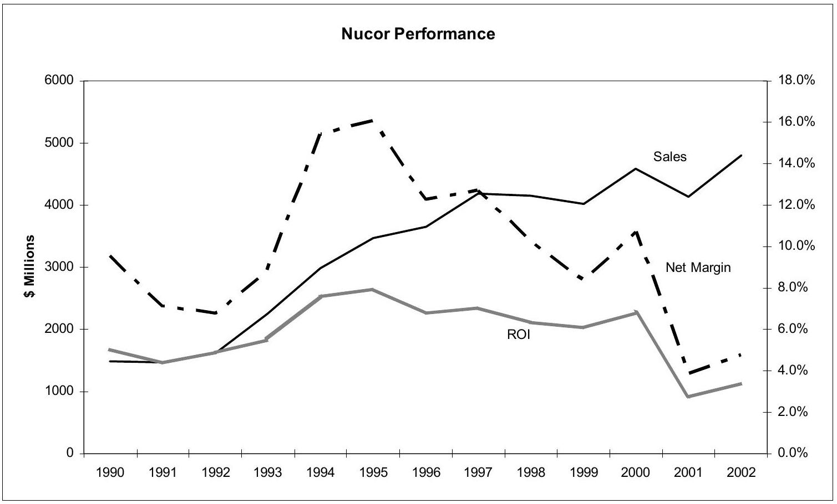
THE CURE FOR THE COMMON MBA Ken Iverson, Plain Talk, John Wiley, 1998.
WE HAVEN'T HAD much luck with the MBAs we've hired out of the top business schools. They've come to us, degree in hand, saying: "I'm ready to conquer the world." So we hired them and found they couldn't conquer the basics of managing a department.
Oh, they're smart enough. They're very good at finance and accounting. They can cite management theories, spout business buzzwords, and diagram models for every occasion. But they have a terrible time talking with an employee who is operating a machine. They just don't know how to relate to and lead people. They lack the basic communications skills.
I imagine Nucor isn't the only company to have had this experience. Something's definitely wrong here. The express purpose of business schools is to turn out competent, professional managers. But they don't. At least, not to my satisfaction.
Part of the problem, I'm sure, is that some MBAs enter the field of management for the wrong reasons. A management career should be about building a business that will survive and succeed over the long term. All too often, though, MBA students seem to focus on the short term, on balance sheet management, and on making deals.
In the late 1970s, for example, I was invited to the Harvard Business School to hear the first presentation of their new case study based on Nucor Corporation. The question posed in the case was: "Should Nucor continue to build minimills in other parts of the country?" We had three mini-mills operating at the time. Today, we have eight.
Well, something like 80 percent of the students concluded that Nucor should not go on building mini-mills. Most felt that we'd never be able to compete with the big steel companies.
After the class, I asked the professor: "Are your students always that conservative? Do they usually have that much trouble seeing what kinds of opportunities might be out there, long term?"
He said, "They really aren't comfortable taking risks that aren't sure to pay off right away. Their idea of success is to get rich quick and retire."
I believe that the attitude among business school students is more entrepreneurial today than it was back then, and that's all to the good. Doing what's good for the business, long-term, should come somewhere ahead of personal enrichment on every manager's list of priorities. So I say to anyone who would pursue a career in management: Don't become a manager if all you want from your career is a quick buck. You'll never be very good at what you do. In fact, the business world would be better off without you.
I have little doubt, though, that many MBAs enter the management profession with admirable motives. They're intrigued by business. They're looking to give more than they receive. They want to contribute. But when they get out into the real world, they find that their schooling has not appropriately equipped them to meet the true demands of management.
That sounds like a condemnation of business schools. It is not. Not entirely. We forget, sometimes, that the "business school" is still in the experimental stage. It is an innovation of the latter twentieth century. What's more, it is predominantly an American innovation. Japan and Germany have relatively few business schools.
In my opinion, the business school is a noble experiment. It may prove a great success some day. All I am saying is that it has not proven a great success yet.
I would urge those who shape business school curricula, then, to consider two basic changes to how their institutions currently educate MBAs:
a) Revamp the core business school curriculum to make room for development of new management skills, especially in the area of communicating with employees;
b) Require at least a one-year, full-time management internship, preferably to be completed in a small business.
Positively influencing human behavior and performance is the most universal of management responsibilities. How can you expect managers to do that when they don't know how to connect to and communicate with people?
Business school curricula should begin with developing managers' ability to understand people and to effectively relate to them. Once MBA students have demonstrated mastery of people management basics, they could move on to tackling the "hard" skills and techniques required for their chosen management
Here are some of the subjects that might form the core of first-year MBA curricula:
Earning Employees' Trust and Loyalty-Far too many managers have no clue how their employees feel or even what their people's work lives are like, day to day. Employees pick up on this lack of insight in a heartbeat, and that realization taints everything their managers say to them from that point forward. Conversely, employees clearly give the benefit of the doubt to managers whom they see as understanding "what's really going on" and "what we're really up against." That's only natural.
I'd suggest, then, that every MBA candidate be required to spend at least a few weeks engaged in manual, clerical, and/or other forms of nonmanagement labor. Further, they should be required to keep a journal of their experiencesthe kinds of problems they encounter, their frustrations, their successes, and so forth. They will find that what seems a small thing to them as managers often takes on great significance to them as employees.
Developing managers should also contemplate the implicit and explicit commitments they will make to the people who work for them. They should understand their obligations under those obligations. And they should grasp the consequences of failing to be consistently trustworthy.
Active Listening-Listening is among the scarcest of all human skills, in and out of management. Listening requires concentration, skill, patience, and a lot of practice.
But such practice is a very sound investment of the developing manager's time. Real listening enables managers not only to hear what people say to them, but to sense what may be behind what is said (i.e., employees' emotions, assumptions, biases). Better still, their reputation for competent listening will encourage others to bring them information.
Listening proficiency is an immense advantage to any manager. No MBA should be sent forth into the business world without it.
The Hazards of Hierarchical Power-Inexperienced managers tend to lean heavily on formal, hierarchical sources of authority. This is understandable. They have not yet had the opportunity to develop other forms of authority such as experience, expertise, and seniority.
The problem is, young managers don't often comprehend the hazards of hierarchical power. They do not understand that, by setting them they may actually be digging themselves into a hole. I think it is only fair, then, that we warn inexperienced managers of the hazards of hierarchical power.
Principles of Equitable Treatment-Few managers receive much in the way of explicit instruction in the principles of equitable treatment of employees, either in business school or in the course of management development. All too often, managers fill that vacuum with their own self-serving precepts of what is equitable. A few common-sense principles, clearly stated and strongly advocated in the business schools, could make the business world a better, more equitable place for employees and managers alike.
The notion of an internship for managers has a precedent in medical education, of course. Doctors intern for a number of years before they are turned loose on the world. There ought to be a comparable transitional step in completing the requirements for an MBA. Further, that transition should focus on providing the management candidate hands-on experience. Any MBA who ventures into business with the intent of managing people should first develop his or her skills under the watchful guidance
The fact is, few business school professors have ever managed anything, and their lack of hands-on experience shows in their students. Medical school faculties, in contrast, are comprised of the best and most respected practicing physicians.
MBA candidates should preferably complete their internships within relatively small, self-contained operations, so they can perceive the operation in its entirety and grasp the overall dynamics of a business. People throughout the corporate world lament that other parts of their company don't understand them or what they do. They're usually right. It takes an extraordinary individual to understand aspects of a business to which he or she has never been exposed. We are expecting far too many managers to be extraordinary.
Some business schools, such as the Fuqua School of Management at Duke University, actively recruit practicing managers, engineers, and other experienced businesspeople into their MBA programs. This is certainly better than conferring MBAs onto those who complete course work but have never managed anyone or anything. But is it enough? Definitely not. A research study cited in a 1997 issue of Business Week found that while 85 percent of business school deans say work experience should be an important consideration in evaluating prospective MBA students, applicants with extensive work experience were somewhat less likely, everything else being equal, to get into the most selective business schools than were candidates with no work experience.
It is time for business schools to explicitly structure actual management time into the MBA curriculum. Nothing short of that will ensure that all of business school graduates emerge truly equipped to manage in the real world.
Meanwhile, I'll go on doing what I can to let business students know that the real world doesn't always match up to what they learn in their course work. I take a lot of phone calls from business students. It's fun. As they get over the
shock of actually reaching me on the first phone call, there's a frantic rustling of papers, then they'll ask, "Um, can we have a copy of your mission statement?" I'll tell them we don't have one, but everyone at Nucor knows what we're trying to do. "Well, then, could you send me some of your job descriptions?" Nucor doesn't have job descriptions. "You don't have job descriptions either?" they say, amazed. "Wait until my professor hears this!"
I just hope business school professors are as ready to learn as are their students.

